EXERCISE – 03 (MULTIPLE LINEAR REGRESSION)
1. AIM
To implement Multiple Linear Regression to predict house prices from several property features and to evaluate the model using a range of regression metrics.
2. ALGORITHM
1. Load the housing dataset and inspect its structure and data types.
2. Convert the categorical columns into numeric form using LabelEncoder.
3. Separate the predictors from the target variable price.
4. Split the data into training and testing sets in an 80:20 ratio with random_state = 42.
5. Train a Linear Regression model on the training data and generate predictions for the test set.
6. Calculate MAE, MSE, RMSE, R², Adjusted R², MAPE, Explained Variance and Maximum Error.
7. Display the intercept and the coefficient of every feature, and predict the price of a new house.
8. Plot the actual prices against the predicted prices.
3. PROGRAM
import pandas as pd
import numpy as np
from sklearn.model_selection import train_test_split
from sklearn.preprocessing import LabelEncoder
from sklearn.linear_model import LinearRegression
from sklearn.metrics import (
mean_absolute_error,
mean_squared_error,
r2_score,
mean_absolute_percentage_error,
explained_variance_score,
max_error
)
data = 'Dataset/Housing.csv'
df= pd.read_csv(data)
df.head()
df.info()
le = LabelEncoder()
for col in df.select_dtypes(include="object").columns:
df[col] = le.fit_transform(df[col])
X = df.drop("price", axis=1)
y = df["price"]
x1, x2, y1, y2 = train_test_split(X, y,test_size=0.2,random_state=42)
model = LinearRegression()
model.fit(x1, y1)
y_pred = model.predict(x2)
y_pred
mae = mean_absolute_error(y2, y_pred)
mse = mean_squared_error(y2, y_pred)
rmse = np.sqrt(mse)
r2 = r2_score(y2, y_pred)
mape = mean_absolute_percentage_error(y2, y_pred)
evs = explained_variance_score(y2, y_pred)
maxerr = max_error(y2, y_pred)
n = x2.shape[0] # Number of observations
p = x2.shape[1] # Number of predictors
adj_r2 = 1 - ((1-r2)*(n-1)/(n-p-1))
print("\n========== Regression Evaluation ==========")
print(f"Mean Absolute Error (MAE): {mae:.2f}")
print(f"Mean Squared Error (MSE): {mse:.2f}")
print(f"Root Mean Squared Error (RMSE): {rmse:.2f}")
print(f"R² Score: {r2:.4f}")
print(f"Adjusted R² Score: {adj_r2:.4f}")
print(f"Mean Absolute Percentage Error (MAPE): {mape:.4f}")
print(f"Explained Variance Score: {evs:.4f}")
print(f"Maximum Error: {maxerr:.2f}")
print("\nIntercept:")
print(model.intercept_)
print("\nCoefficients:")
coef = pd.DataFrame({
"Feature": X.columns,
"Coefficient": model.coef_
})
print(coef)
new_house = [[5000,3,2,2,1,1,0,1,0,1,0,1]]
prediction = model.predict(new_house)
print("\nPredicted House Price:", prediction[0])
import matplotlib.pyplot as plt
plt.figure(figsize=(6,6))
plt.scatter(y2, y_pred)
plt.plot([y2.min(), y2.max()],
[y2.min(), y2.max()],
'r--')
plt.xlabel("Actual Price")
plt.ylabel("Predicted Price")
plt.title("Actual vs Predicted Values")
plt.show()

4. OUTPUT
The program was executed on the Housing dataset (Housing.csv) and produced the following output:
price area bedrooms ... parking prefarea furnishingstatus
0 13300000 7420 4 ... 2 yes furnished
1 12250000 8960 4 ... 3 no furnished
2 12250000 9960 3 ... 2 yes semi-furnished
3 12215000 7500 4 ... 3 yes furnished
4 11410000 7420 4 ... 2 no furnished
[5 rows x 13 columns]
<class 'pandas.core.frame.DataFrame'>
RangeIndex: 545 entries, 0 to 544
Data columns (total 13 columns):
# Column Non-Null Count Dtype
--- ------ -------------- -----
0 price 545 non-null int64
1 area 545 non-null int64
2 bedrooms 545 non-null int64
3 bathrooms 545 non-null int64
4 stories 545 non-null int64
5 mainroad 545 non-null object
6 guestroom 545 non-null object
7 basement 545 non-null object
8 hotwaterheating 545 non-null object
9 airconditioning 545 non-null object
10 parking 545 non-null int64
11 prefarea 545 non-null object
12 furnishingstatus 545 non-null object
dtypes: int64(6), str(7)
memory usage: 55.5 KB
[5203691.70963178 7257004.02115476 3062828.59668172 4559591.65374424
3332932.30559782 3563080.67918997 5645466.31219972 6413979.66873635
2755831.54819 2668938.66075229 9570600.29915353 2827431.50860062
3195686.2583409 3352263.99438471 3713879.49996131 5301088.24435749
2987920.2666968 4810799.8212371 4383031.70489929 3525092.18938646
5796259.50068013 5840000.70299301 2760214.608641 4762590.14920607
5204755.73895206 7515542.71619025 3254681.68956382 5236164.45964444
8178523.16820284 3434166.15675649 6443921.58767581 3346004.77919184
6742324.74004133 4154936.84088665 3589152.47491253 5788125.92515323
4768370.18154076 4391684.04193172 3217657.04549935 4638196.61928878
4522160.27786714 3541284.06127245 7238136.11941171 4021515.68926614
3701978.76822757 4298879.55563098 6705004.02060611 3993466.52296897
3798185.05328059 3451821.5624289 7293996.86867461 2832905.26972678
4378698.14769931 4468002.85418353 3714623.89765883 2718466.90282779
7524449.64983626 2950437.1495281 4194596.28592921 2795827.77318101
4801788.72577028 3618230.29875972 5091685.77019752 4248122.70647651
4729964.20281946 4620982.9363411 7215846.76983926 3485106.19132682
5933820.14349914 6236580.98095548 4809923.61015999 5130920.22938947
4527282.87392583 8006869.07208366 3543927.63713716 5463086.05281817
3902441.28505163 4661063.63495886 4825370.89331733 4276803.47099967
7754072.71344458 4008573.23235629 6500977.91345038 5386796.00909808
2785343.0092764 6836356.36771846 2638553.49378047 3634231.99215348
8004072.41154001 8048399.75418244 3227573.69687309 5935167.4198354
3605772.48317455 3817767.91420862 7631673.34074558 4775106.62670537
5093491.44442931 6447437.14797692 4943449.6813564 5943929.14295426
3810460.26405425 6457426.32302761 3701491.23218178 5960492.47343074
4933137.14530295 4377133.13624287 7009335.02696999 6351460.97128317
6409340.41089671]
========== Regression Evaluation ==========
Mean Absolute Error (MAE): 979679.69
Mean Squared Error (MSE): 1771751116594.03
Root Mean Squared Error (RMSE): 1331071.42
R² Score: 0.6495
Adjusted R² Score: 0.6057
Mean Absolute Percentage Error (MAPE): 0.2131
Explained Variance Score: 0.6534
Maximum Error: 5295927.59
Intercept:
293083.0691506695
Coefficients:
Feature Coefficient
0 area 2.358488e+02
1 bedrooms 7.857449e+04
2 bathrooms 1.097117e+06
3 stories 4.062232e+05
4 mainroad 3.668242e+05
5 guestroom 2.331468e+05
6 basement 3.931598e+05
7 hotwaterheating 6.878813e+05
8 airconditioning 7.855506e+05
9 parking 2.257565e+05
10 prefarea 6.299017e+05
11 furnishingstatus -2.103971e+05
Predicted House Price: 6017942.931156618
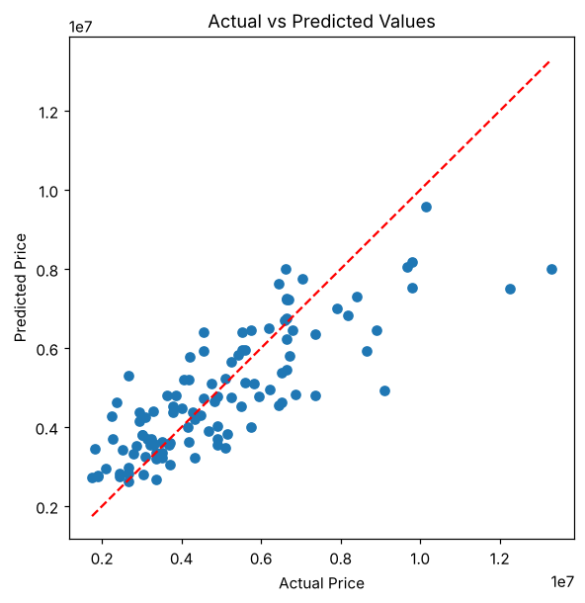

5. RESULT
Thus, the Multiple Linear Regression practical was implemented successfully. The model obtained an R² score of 0.6495 (Adjusted R² 0.6057), an MAE of 979679.69 and an RMSE of 1331071.42 on the test set. The number of bathrooms had the largest coefficient, and the predicted price for the sample house is 6017942.93.

